Title (14pt, Bold, Normal, Centered)
Title of your work should be very concise and meaningful because titles of the manuscripts are often used to search the required contents by the users so avoid using formulas, abbreviations and jargons where possible

First Author¹ (Corresponding Author), Second Author², Third Author³ (12pt, Bold, Normal, Centered)

Please specify properly the designation of each authors, the Institution / University name included in this part the full postal addresses of authors’ each affiliation which include city and country name.
¹First Author Affiliation (10pt, Italics)
²Second Author Affiliation (10pt, Italics)
³Third Author Affiliation (10pt, Italics)
Email Id: Specify working Email Id of each authors (10pt, Italics)

Abstract (14pt, Bold, Normal)
This document is for preparing an accepted paper / manuscript of arts, humanities and science for International Journal of Arts, Humanities, Literature and Science. Authors are requested to use this template for preparing their final version of the paper / manuscript. This document also gives the instruction for preparing the manuscript for submission. There should be 150-250 words in the abstract, although authors can be allowed to furnish paper / manuscript with a slightly lower or higher word count for the abstract depending on the nature of the paper / manuscript and the research. However, authors should keep in mind that an abstract of the paper / manuscript is a brief paragraph of text, which highlights the value of their paper / manuscript and the research. Writing a perfect abstract may be a challenging task with the limited freedom on space, try your best to include meaningful and complete sentences instead of less readable and out of context phrases, which makes the abstract less coherent. Consider the appropriate grammar. Often abstract is written in the past tense. DO NOT USE SPECIAL CHARACTERS, SYMBOLS, OR MATH IN YOUR TITLE OR ABSTRACT.

Keywords: Three to Five keywords/phrases are to be provided for indexing purposes. Be very careful while using abbreviations in keywords; use only those abbreviations which are resolutely recognized in the field of study.

1. INTRODUCTION (Headings 12pt, Bold, Normal)
This template, modified in MS Word 2007 and saved as “Word 97-2003 Document” provides authors with most of the formatting specifications needed for preparing electronic versions of their papers. All manuscripts must be in English. Authors are advised to provide an introduction for their paper / manuscript. Introduction can be considered as the first detailed statement about the research topic being discussed in a general context. The introduction is a place to present those to the reader for the first time. It is not constrained such as the abstract. Hence authors can express their ideas without worrying about the space. The introduction is better when written in a brief manner with sufficient information to convince the reader at the early stage. However, try not to over explaining the same topic or repeat unnecessarily instead use a separate background section if you have enough materials to discuss after the introduction. Always end your introduction section with an outline of the paper with brief details on each. The formatter will need to create these components, incorporating the applicable criteria that follow. Section 2 of this paper explains about the Body of the article while several subsections are included to explain subsections, language use, and referencing. Section 3 explains formatting on Type of style and Font, Units, Abbreviations, Figures, Table and Equations with examples. Finally, the section 4, concludes the main text while references and author biography completes the paper / manuscript.
2. BODY OF THE ARTICLE (Headings 12pt, Bold, Normal)

Authors are free to extend the main body text and sections as appropriate with suitable section/subsections. Do not include unnecessary spaces or indentations between or within paragraphs, sections or subsections other than what have been included in this template. Do not use additional styles or font settings other than the used. Please refer the Table1 for further details on font styles and sizes

2.1 Subsections must be in sentence case (Sub Headings, 11pt, bold, Italics)

It is important that authors divide their sections into sub sections in an appropriate manner. Having subsections help to improve the readability, presentation and the comprehension of the article. Subsection headings must be carefully and appropriately chosen, ideally, with a lesser number of words. To achieve this, authors can focus on the content, subject topic, and results that are being discussed in that particular subsection.
2.2 Language use (Sub Headings, 11pt, bold, Italics)
Manuscripts should be typed in MS Word, should be in English and should be sent online only via e-mail .Please be consistent with the language use. The Journal accepts English (UK) as the official language format for its publications, although English (US) is also allowed. Authors should not switch from one format to another, instead, please be consistent with the style that you have selected at the beginning. This can be easily assisted by setting the appropriate language setting for your word processing document or following the style used in this template.
2.3 Length of paper (Sub Headings, 11pt, bold, Italics)
The length of the paper should not exceed 20 pages. Paper containing more than 20 pages words will be returned to the author(s) to abridge. Articles should be typed with line spacing Multiple spacing at 1.15 with spacing after 6 pts {refer Image Below} (including footnotes and references) on one side of the paper only (preferably A4) with wide margins. Authors are urged to write as concisely as possible, but not at the expense of clarity.
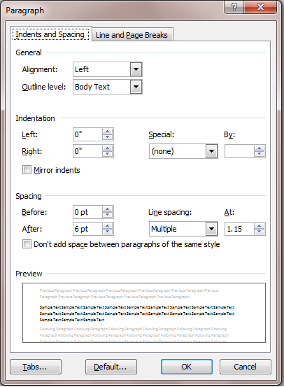
Figure: 2 Paragraph Style
2.4 Reference and citations
Reference citations in the text should be identified by numbers in square brackets. Some examples:
1. Negotiation research spans many disciplines [3].
2. This result was later contradicted by Becker and Seligman [5].
3. This effect has been widely studied [1-3, 7].
After appropriate referencing in the body of the text list them in numerical order at the references section. For example if the fist reference is mentioned in square bracket as [1], the same [1] has to be listed as first in the reference section. Wherever an author faces a problem of citation of a web reference, please include the full URL as a minimum. Please try to use accurate information on references, as it helps reviewers and readers. It is authors’ responsibility to facilitate the Journal Editors to maintain the quality of the blind review process
3. FIGURE LEGENDS, FIGURES AND SCHEMES
Place figures and tables at the top and bottom of the columns. Number Figures consecutively as Figure 1, Figure 2, etc. with respect to their appearance order. Figure captions should be placed below the figures; if your figure has two parts, include the labels “(a)” and “(b)” as part of the figure. It is your responsibility to ensure that the referred figures in the text actually appear. In text, refer figure as "Figure 1,"
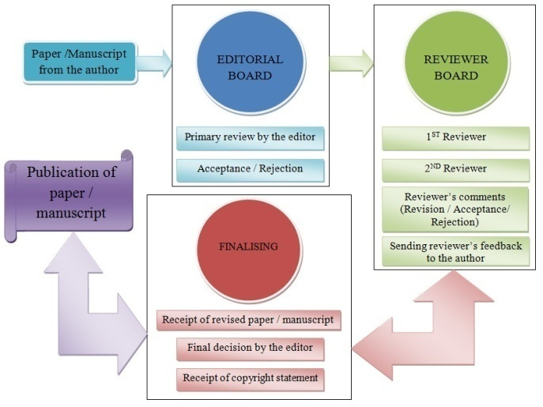
Figure: 2 IJAHLS review process
3.1 Tables
Number Tables consecutively as Table 1, Table 2, etc. with respect to their appearance order. Title of the Table should always be placed at the top of the Table. Place figures and tables at the top and bottom of the columns. Avoid placing them in the middle of columns. Insert figures and tables after they are cited in the text. Table 1 shows some styles for the paper / manuscript.

Font Size |  | Details
14 | Title | Title case, bold font
12 | Author’s name | Bold font
12 | Section Headings | Sentence case, bold font, Capital letters
11 | subsections | sentence case, bold font and in italics
10 | Body text*, table and figure captions, equations, etc. | No special formatting or styles (except bold and italic as required for the clarity)
10 | Author Affiliations
9 | Reference
Line Spacing Multiple at 1.15
* Body text should be justified

Table: 1 Format guidance’s
3.2 Formula
The text size of the formula, if any, should be similar to the normal text size of the manuscript.
Tables should be placed similar to figures, i.e. at the top or bottom of the columns. Equations should be numbered consecutively with equation numbers in parentheses flush with the right margin, as shown in (1). It may be a good choice to use a mathematical equation editor available in the word processing tool to prepare your equations instead of textual expressions. An equation that was written using Microsoft Equation Editor is shown in (1).

(1)
Under circumstances where Microsoft Equation Editor is not needed to be used, you can determine your equation either the Times New Roman or the Symbol font (please no other font). Use a long dash rather than a hyphen for a minus sign. Punctuate equations with commas or periods when they are part of a sentence as in.
                                                                           
Note that the equation is centered using a center tab stop. Be sure that the symbols in your equation have been defined before or immediately following the equation.

4. SOME COMMON MISTAKES
- The word “data” is plural, not singular.
- The subscript for the permeability of vacuum μ₀, and other common scientific constants, is zero with subscript formatting, not a lowercase letter “o”.
- In American English, commas, semi-/colons, periods, question and exclamation marks are located within quotation marks only when a complete thought or name is cited, such as a title or full quotation. When quotation marks are used, instead of a bold or italic typeface, to highlight a word or phrase, punctuation should appear outside of the quotation marks. A parenthetical phrase or statement at the end of a sentence is punctuated outside of the closing parenthesis (like this). (A parenthetical sentence is punctuated within the parentheses.)
- A graph within a graph is an “inset”, not an “insert”. The word alternatively is preferred to the word “alternately” (unless you really mean something that alternates).
- Do not use the word “essentially” to mean “approximately” or “effectively”.
- In your paper title, if the words “that uses” can accurately replace the word “using”, capitalize the “u”; if not, keep using lower-cased.
- Be aware of the different meanings of the homophones “affect” and “effect”, “complement” and “compliment”, “discreet” and “discrete”, “principal” and “principle”.
- Do not confuse “imply” and “infer”.
- The prefix “non” is not a word; it should be joined to the word it modifies, usually without a hyphen.
- There is no period after the “et” in the Latin abbreviation “et al.”
- The abbreviation “i.e.” means “that is”, and the abbreviation “e.g.” means “for example
5. CONCLUSION (Headings 12pt, Bold, Normal)
Authors are expected to conclude their presentation comprehensively in the conclusion. Authors have the freedom to include future research details as part of the conclusion or as a separate section before the conclusion, depending on the appropriateness. Conclusion should not repeat the main text; instead it should try to help the reader to have a strong view on the article’s claims. Following a critical approach on own research methods and experiments can show maturity and impartial evaluation, which enhance the quality of your article.
6. SPONSORING INFORMATION (Headings 12pt, Bold, Normal)
If the submitted research work is sponsored or supported in any way by an organization or an NGO, please mention it.
A Brief Author Biography (Optional)

1st Author Name (Corresponding Author) – A brief biography including qualifications, research interests, and any other information that the author wishes to include. Biography should be less than 150 words.

2nd Author Name – A brief biography including qualifications, research interests, and any other information that the author wishes to include. Biography should be less than 150 words.

3rd Author Name – A brief biography including qualifications, research interests, and any other information that the author wishes to include. Biography should be less than 150 words.

